Volunteers’ Management System
Software Architectural Description

Spring 2010

Table of Contents

Content Page #

Table of Contents 2
1 Introduction 3
1.1 Purpose 3
1.2 Scope 3
1.3 References 3
1.4 Overview 3
2 Architectural Goals and Constraints 5
2.1 Stakeholders and concerns 5
2.2 Key Requirements 6
3 Use Case View 9
4 Logical View 10
5 Process View 13
6 Deployment View 15
7 Implementation View 16

Introduction

Purpose
The purpose of this architectural description document is to define the architecture of the VMS.
Several outcomes are expected from this document;
- This document constitutes a base for the detailed design specification
- All of the stakeholders can have a clear understanding of the VMS architecture
- Any new developer can easily understand the overall structure and start development quickly

Scope
The architecture described covers the VMS web application, database and VMS mobile application.

References
- Paul Clements, Comparing the SEI’s Views and Beyond Approach for Documenting Software Architectures with ANSI-IEEE 1471-2000, Software Architecture Technology Initiative, July 2005
- Nicholas May, A Survey of Software Architecture Viewpoint Models, http://www.mindward.com/blog/archives/pdf/may.pdf, 2010.03.10
- IEEE Standard ISO/IEC 42010:2007(E) Std 1471-2000, Systems and software engineering — Recommended practice for architectural description of software-intensive systems, 2007.07.15
- RUP Software Architectural Description Document Template, http://www.ts.mah.se/RUP/RationalUnifiedProcess/wordtmpl/rup_wd_tmpl.zip, 2010.03.10
- Paul Clements, Documenting Software Architectures, 2001.11.01

Overview
“A software architecture is a complex entity that cannot be described in a simple one-dimensional fashion.” (P. Clements, Documenting Software Architectures, 2001). To describe an architecture, several approaches has been proposed of which the most recognized one is 4+1 approach. 4+1 approach is originally proposed by Philippe Kruchten, then become a basis for IEEE recommended practise for architectural description of software intensive systems.

This document also follows the widely accepted 4+1 approach. VMS architecture is given in 4 different views;
- Logical view: Represents the layering structure of the system.
- Process view: Describes the common request-response process and more specifically, the fundamental characteristics of automatic requesting process.
- Deployment view: Shows the deployment structure of the VMS.
- Implementation view: Explains the development environment covering different projects and relation between them.
In order to connect the rationale behind these views, a +1 view is suggested by the founder of the approach. Use case view fulfils that connection purpose.

Hence, the document structure is consistent with the 4+1 approach. In the first part, important objectives for the architecture are analysed. Some problems are discussed. Then different concerns of the stakeholders are studied, the issues related to architecture are defined. Afterwards, two key requirements are examined.

In the second part, 4+1 views are given with the contents that are given above.

Architectural Goals and Constraints

Stakeholders and concerns

Several different parties can be counted that are concerned with the functionality of VMS such as local government, police or hospitals. However we can assume that their demands are shared with the authorized help organization in the crisis area. Thus, only crisis manager can represent all of them. So, we will examine the concerns of crisis manager as a stakeholder from architectural aspect.

Beside the crisis manager, the second stakeholder of VMS is volunteer. These two main users of VMS will be analysed to see the important points of the architecture.

Volunteer
Volunteers are general public. They include technical people as well as ordinary people. However, the majority consists of ordinary people. This implies that the usage should not be difficult.

The mobile devices the citizens use differs in different aspects. The two most important aspects of the mobile devices are; processing power (including memory) and internet connection speed. The distribution of the mobile devices in terms of these aspects is important to design an efficient architecture for VMS and must be researched very well. The affects of these aspects can be visualized as following table:

 | Low CPU and memory  ~< XXX mhz. <Xmb | High CPU and memory
Slow internet connection  usually GPRS, ~< 20kb | Problematic, very limited usage of the system.  - Image and video uploading must be excluded.  - CPU consuming operations (e.g. compression) should not be used. | Partly problematic, without big data transfer.  - Image and video uploading must be excluded.  - Compression can help data transmission
Fast internet connection  CDMA, EDGE, UMTS..,~>50 | Little problematic, without CPU requiring operations.  - CPU consuming operations (e.g. compression) should not be used.  - Complex forms and screens must be carefully used. | Ideal conditions. No limit.
Table 1. CPU vs. Internet Connection Analyze of Mobile Devices
Besides CPU and internet connection, camera quality is also important for an effective usage of VMS. High camera resolution produces big images and video files. There should be a standard for image and video resolution. Since the big images and videos affect transmission and also server side work load, there should be a size reduction at either client side before sending or at server side before sending.

The number of volunteers that can connect simultaneously is another concern for VMS. The connection can be regarded as either active connection or passive connection. The situation that volunteer opens the application and waits for a request means passive connection and the situation that volunteer sends any data (e.g. report) means active connection.

The data size required by each connection types differs sharply. Since the communication will be held by web services, passive connection only requires periodic checks of the system by calling web services while active connection consumes most of the available bandwidth of the device. The overall bandwidth requirement is discussed in Key Requirements section below.

Crisis Manager
Crisis manager is an expert on managing crises. They know the characteristics of different crisis.

The key factor for the crisis manager is time.

Since the crisis are rush hours, many incidents must be managed so quickly with as few steps as possible. The user interface for crisis manager must contain as much information as possible. This might not seem true since it will lead to a difficult-to-understand system however for the crisis manager, speed of the usage overcomes the learnability factor.

The interfaces for crisis manager will be mainly for managing and monitoring incidents. Since the information will be updated so frequently by volunteers, these interfaces should be updated automatically. In the world wide web, automatic update are done by refreshing. So the information in the interface must be refreshed automatically. The refresh rate is questionable. Different sections of the page can require different refresh rates. For a comprehensive interface that includes many different information, the best update strategy can be using Ajax.

Developer
The most important concern the developers of VMS have is the maintainability. The architecture as well as development environment must be planned in such a way that any new coming developer can understand and continue development in a short time.

Key Requirements

Maximum number of connections
The supplementary specification of VMS requires 12.000 passive or active connections at any given time. Since the active and passive connections differ significantly, they should be analysed separately.

For an optimistic situation, instead of 12.000, 50.000 passive connections must be supported. Assuming a simple web service call as 5kb in size, 50.000 simultaneous web service call results in 25mb transfer requirement, which is not an important bandwidth for a typical web server. However, it still means 50.000 web service method call simultaneously. Internal design of the web services must be thought carefully.

The web service call rate is another important factor affecting the performance of the system. Even though this rate differs between 5 and 10 second, it is better if it is adjustable by server side.

The 12.000 active connections, which implies that 12.000 volunteers transfer data (e.g. report) at the same time, is not realistic. However, we can assume 3% of all volunteers will be active transferring data. For our optimistic 50.000 volunteers, this makes 1.500 active connections. Assuming any active connection will function with the available bandwidth of mobile device, 1.500 active connections will require 1.500 x 50kb=75mb bandwidth for the 50kb average mobile device bandwidth. Most of the advanced web servers support this capacity and it doesn’t require any special consideration.

Automatic Requesting
One of the special features of VMS is automatic requesting. It implies automatically continuing requesting until the needed resources are gathered.

A request is shown to a specific set of volunteers initially. Then volunteers respond to the request and the system updates the database according to the changes.

Automatic requesting occurs if a volunteer doesn’t accept the request or he/she doesn’t respond to it. For both of the situations, system must choose another volunteer, send a new request and do the same things for the new request. The requesting operation for a single volunteer can be seen from following activity diagram.

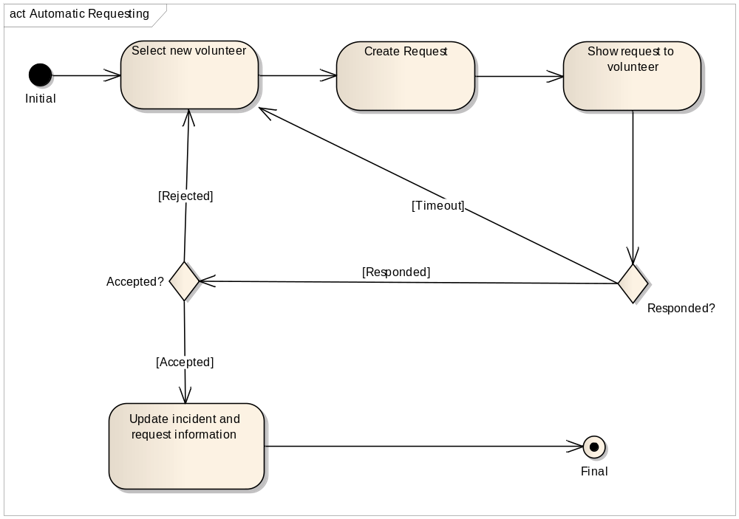
Figure 1. Requesting operation for a single volunteer.

Use Case View

Logical View
There are few criteria that should be considered carefully for designing the architecture of VMS.

- First of all, the system should be maintainable allowing future changes easily. The layered structure can achieve this goal separating different parts. Thus overall architecture becomes easier to understand and to modify.

- Testing is also another factor that must be taken into account by the architect. A good architecture contains details about testing. The VMS layers are designed to have a testing layer. Additionally, all the logical operations which are important to be tested, gathered together in one layer. Thus testing these logical operations as well as maintaining them become easier.

- The scalability is also important since VMS can be used for very big cities as well as town-size cities. Hardware and software must be scalable to meet different level of work load. Separating the web service into different layer assures the maintainability. Thus, multiple web services can be deployed if needed to fulfil big workloads.

- Database is among the most important factors for performance and also to meet different size of organizations. Designing the system as loosely coupled with any database vendor allows meeting different capacities. Separating the data access into a separate layer aims this purpose. To go one step further in having completely flexible database structure, an O/R mapping framework must be used. NHibernate and Entity Framework of Microsoft are the recognized options for O/R mapping framework. Entity Framework of .Net framework was chosen to be used for object to database mapping. Thus different database vendors can be supported aiming different capacities.

- The last factor for the architecture is the ease of development. Programmers and designers should be able to work simultaneously. VMS architecture allows this by completely separating the user interface and business logic. The role of the user interface is only to direct and data flow to the actual business layer.

The proposed layered architecture of VMS which achieves the counted criteria is expressed as in following figure. The short explanation of the layers can be found below.

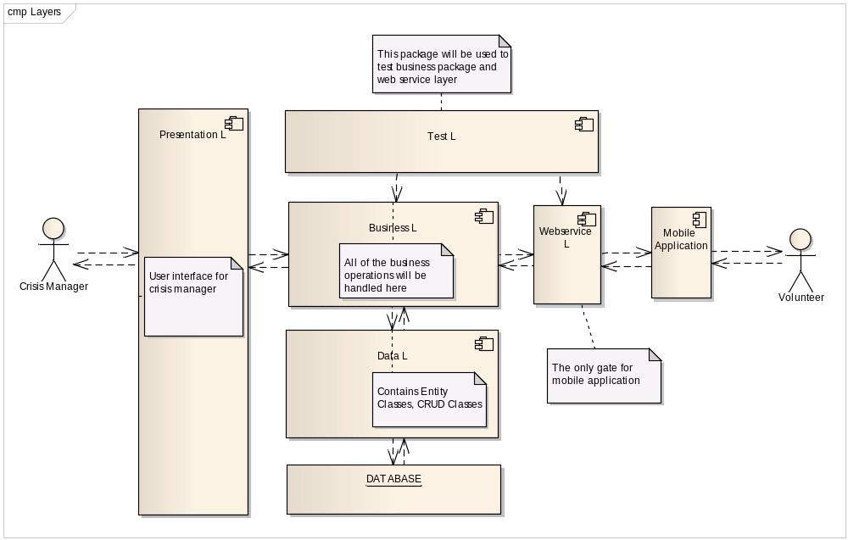
Figure 2. Logical View of VMS
Presentation Layer
This layer contains only the web pages. The role of the layer is only forwarding the user actions to the business layer. Since it is very difficult to test web pages, no testing plan is included for presentation layer.

For the ease of development, some common operations such as logging and security checks will be situated in base classes. And master pages will ensure an easy to modify design structure.

The proposed internal structure of the presentation layer can be seen in following diagram.

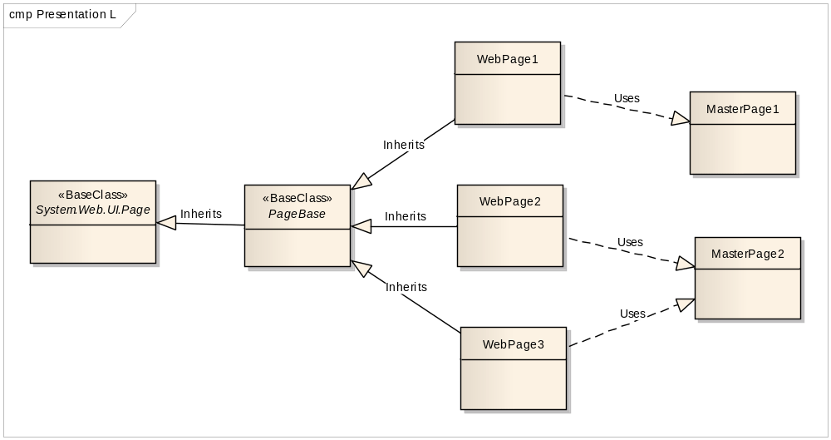
Figure 3. Internal structure of the presentation layer.
Data Layer
The responsibility of data layer is to provide access to the database. Since an O/R mapping framework will be used, all of the entity classes as well as mapping classes will be put in this layer.

Web Service Layer
This layer can be thought as a gate for the mobile application. The communication between server and mobile application will be done via web services. Deploying more than one web services will allow fulfilling different working scales.

Business Layer
All of the business logic will reside here. Any action of the crisis manager and web service calls of mobile application will be directed to this layer. Hence, this is the most important layer to be tested.

Test Layer
An ideal architecture is the one that is easy to be tested. VMS architecture contains a test layer to ensure enough testing is done and to provide more confidence. This layer has two target to test; business layer and web service layer. Business layer contains the most important operations that needs testing and web service layer is good to have testing. This test layer only remains in development environment and will be excluded from the final release.

Process View
All of the typical web applications work as request-response system. When a request reaches to the server, required objects are created in the memory, request is processed and all of the resources are released. This is also valid for VMS. Mobile application will use web services to communicate with server. The communication will be done as request-response manner. Each time a request comes to the server, a process runs to prepare the response, then it is released. Besides the classical http request-response process, VMS has one more process which continuously runs and processes automatic requesting.

A request can have four states:
- Waiting to be answered.
- Accepted
- Rejected
- Not answered within timeout period.

Hence, a process should check the states of all of the requests. The accepted and rejected responses don’t require any special action by automatic requesting process. The required action will be triggered by the answers. However, the state that the request is not answered within timeout period must be observed and the required actions must be performed by a continuously running process which is automatic requesting process. This process will run continuously to check the states of the requests periodically. The rate for checking the status of the requests is configurable. At each checking cycle, all of waiting requests should be checked for timeout. If any request is timed out, then a new request for a new volunteer should be created. Since gathering required data from database to see the status of requests consumes an important resource, internal structure of checking algorithm must be carefully analysed considering possible caching techniques.

The following activity diagram depicts the steps and context of automatic requesting operation.

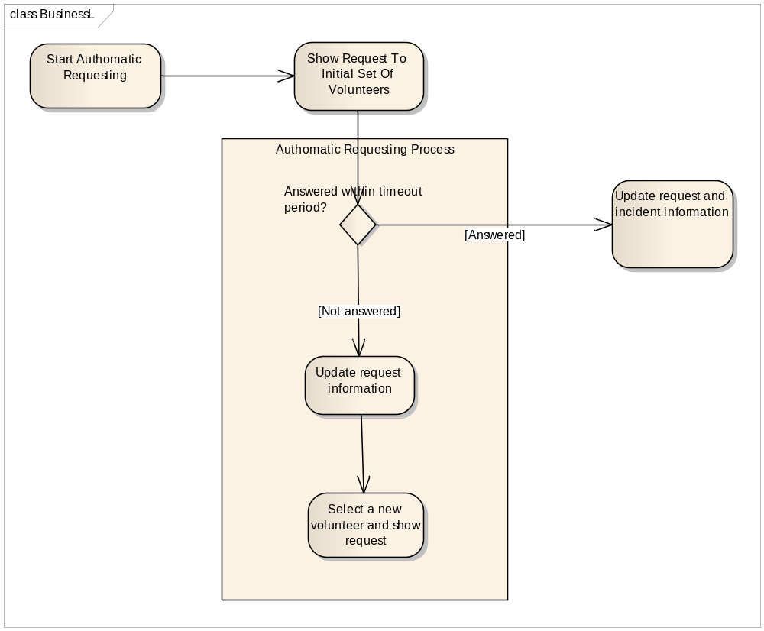
Figure 4. Automatic requesting process

Deployment View
The minimum required environment for VMS must contain;
- a web server for management web application and web services
- a database server
Although that shows one web server is enough to handle both managerial tasks and web service calls, in order to increase performance and capacity, different web servers can be used to divide work load into several machines.

Database server can be deployed to any machine that has a fast connection to the web servers. It is also possible to setup database on the same machine with web server. Thus VMS can operate on one single machine.

An ideal deployment diagram is given below to visualize the deployment view of VMS.
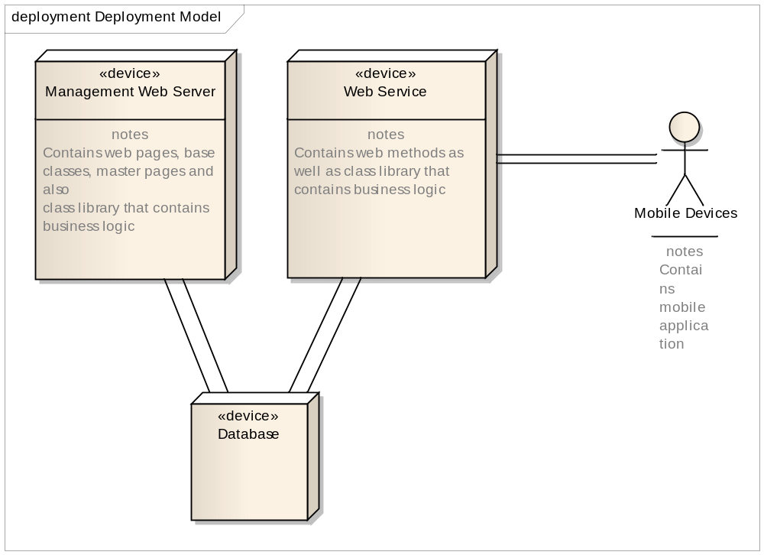

Implementation View
VMS is a composite system that includes .Net and Java softwares. Server side and mobile side are developed as two different softwares connecting each other via web service at the server side. Thus there are two different development environment.

Server side development environment
.Net is the selected language for server environment including web site for crisis manager, web services and business logic.

Visual Studio 2010 is the main development tool to be used. A visual studio solution is created as a container for all server side projects. The projects in this solution are;
- A web application, including web pages and web services
- A class library project to contain all of the business logic.
- A console application for testing the class library.

To fulfil wider capacity and serve more volunteers, the web service could be easily separated into another web project, thus that project can be deployed to many different servers.

Mobile application side
As most of the mobile devices support java, mobile application for VMS is being built with Java.

Netbeans IDE by SUN is the development tool for mobile application.

Synchronization and change management
To have the latest state of code and to track the changes in the code, subversion is used. Since the development team is small, containing 7 people, no access rights are set in subversion allowing all of the team members to make any modification to the code.

